NEW PATIENT FORM
George J. Mundanthanam MD
Name: Age: Date of Injury: Height: Weight:
Referral Source: ☐Family Physician ☐ER Physician ☐Family/Friend ☐Insurance ☐Internet
Reason for Today’s Visit:

Please mark the severity of pain you are currently experiencing on a scale from 0(no pain) to 10 (severe pain)
Current Pain: Choose an item. ☐0 ☐1 ☐2 ☐3 ☐4 ☐5 ☐6 ☐7 ☐8 ☐9 ☐10
Pain with Activity: Choose an item. ☐0 ☐1 ☐2 ☐3 ☐4 ☐5 ☐6 ☐7 ☐8 ☐9 ☐10

Please mark on the diagram the location of the pain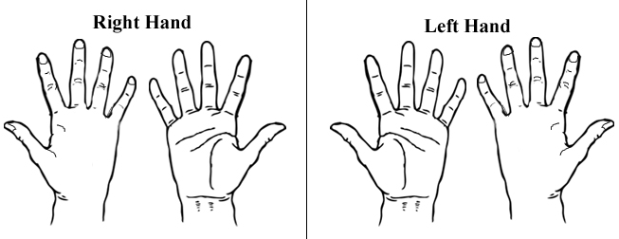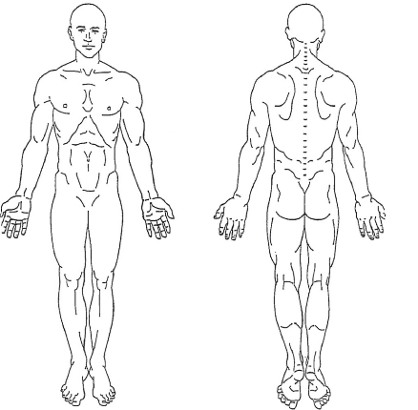

Please describe the type of pain, sensation, or symptoms you are currently experiencing (Circle all that apply):

☐Aching ☐Shooting ☐Burning ☐Stabbing ☐Cramps ☐Stiffness ☐Dull ☐Numbness ☐Throbbing ☐Sharp ☐Tingling ☐Dropping things ☐Weakness ☐Other:

Medical Problems: (ex: Diabetes, high blood pressure, asthma etc.)
What Surgeries have you had in the past (include procedure and year performed):

Medications Dose Frequency

Are you allergic to any medications: ☐YES ☐NO
If yes, please list the medicine and type of reaction:
What is your occupation:

Do you currently smoke cigarettes: ☐YES ☐NO If yes, how many packs per day? How many years?
Do you drink? ☐YES or ☐NO How often? ☐Rarely ☐Occasionally ☐Socially ☐Daily

Family History: Mom: ☐Alive or ☐Deceased Father: ☐Alive or ☐Deceased
Which family members have any of the following (circle all that apply):
Mom: ☐Osteoarthritis ☐Rheumatoid Arthritis ☐High Blood Pressure ☐Heart Disease ☐Diabetes ☐Cancer ☐Lupus ☐Stroke
Other:
Dad: ☐Osteoarthritis ☐Rheumatoid Arthritis ☐High Blood Pressure ☐Heart Disease ☐Diabetes ☐Cancer ☐Lupus ☐Stroke
Other:
Grandmother: ☐Osteoarthritis ☐Rheumatoid Arthritis ☐High Blood Pressure ☐Heart Disease ☐Diabetes ☐Cancer ☐Lupus ☐Stroke
Other:
Grandfather: ☐Osteoarthritis ☐Rheumatoid Arthritis ☐High Blood Pressure ☐Heart Disease ☐Diabetes ☐Cancer ☐Lupus ☐Stroke
Other:

Review of Systems:
GENERAL: SKIN:
Weight Change ☐YES ☐NO Rash ☐YES ☐NO
Fever ☐YES ☐NO Sores ☐YES ☐NO
Night Sweats ☐YES ☐NO Easy Bruising ☐YES ☐NO
Loss of Appetite ☐YES ☐NO CARDIOVASCULAR:
NEUROLOGIC: Chest pain ☐YES ☐NO
Numbness or Tingling ☐YES ☐NO Dizziness or fainting ☐YES ☐NO
Weakness ☐YES ☐NO Palpitation ☐YES ☐NO
Seizures ☐YES ☐NO RESPIRATORY:
EAR EYE NOSE THROAT: Cough ☐YES ☐NO
Visual changes ☐YES ☐NO Shortness of breath ☐YES ☐NO
Hearing changes ☐YES ☐NO Wheezing ☐YES ☐NO
Hoarsness ☐YES ☐NO ALLERGY/IMMUNOLOGY:
GENITOURINARY: Food Allergies ☐YES ☐NO
Burning Urination ☐YES ☐NO Latex Allergies ☐YES ☐NO
Urinary Frequency ☐YES ☐NO Frequent Infections ☐YES ☐NO
Incontinence ☐YES ☐NO PSYCHOLOGIC:
GASTROINTESTINAL Depression: ☐YES ☐NO
Heartburn ☐YES ☐NO Anxiety: ☐YES ☐NO
Constipation ☐YES ☐NO
Diarrhea ☐YES ☐NO
Blood in stool ☐YES ☐NO
George J. Mundanthanam MD
Please Print Information/Fill in all Blanks
PATIENT INFORMATION
Patient Name (Last, First, Middle)

Sex: ☐Male ☐Female Marital Status: Date of Birth:

Email Address:

Address: City-State-Zip:

Phone# Cell#

In Case of Emergency Notify: Relationship: Phone#

PRIMARY Insurance Policy Holder Name: Relationship:

Phone#: Date of Birth:

Address: City-State-Zip:

SECONDARY Insurance Policy Holder: Relationship:

Phone#: Date of Birth:

Address: City-State-Zip:

In the event this claim is denied by my insurance company I understand that I am responsible for all charges incurred as a result of this visit. I hereby authorize the above physician to release information to my employer and insurance carrier. I hereby authorize payment directly to the above provider of the surgical and medical benefits if any, otherwise payable to me for his services, but not exceed the reasonable and customary charges for all those services. I understand that this authorization does not release me from my personal responsibility for payment of all charges.

Signed (Patient or Insured) (Parent signature required for minors)

Signature: Date:

George J. Mundanthanam, MD PA
NOTICE OF PRIVACY PRACTICES ACKNOWLEDGEMENT
PATIENT CONSENT FORM

I understand that, under the Health Insurance Portability and Accountability Act of 1996 (HIPPA), I have certain rights to privacy regarding my protected health information. I understand that this information can and will be used to:

*Conduct, plan and direct my treatment and follow-up among the multiple healthcare providers who may be involved in that treatment directly and/or indirectly.
*Obtain payment from third-party payers
*Conduct normal healthcare operations such as quality assessments and physician certifications

I have been informed by you and your Notice of Privacy Practices containing a more complete description of the uses and disclosures of my health information. I understand that this organization has the right to change its Notice of Privacy Practices from time to time and that I may contact this organization at any time at the address above to obtain a current copy of the Notices of Private Practices.

I understand that I may request in writing that you restrict how my private information is used or disclosed to carry out treatment, payment or health care operations. I also understand you are not required to agree to my requested restrictions, but if you do agree then you are bound to abide by such restrictions.

I understand that I may revoke this consent in writing at any time, except to the extent that you have take action relying on this consent.

Can we call you at home? ☐Yes ☐No
Can we leave you a message at home? ☐Yes ☐No
Can we leave you a message on your answering machine/voicemail? ☐Yes ☐No
Can we call you at work? ☐Yes ☐No
Can we leave you a message at work? ☐Yes ☐No

I authorize your office to disclose the specific information, only for the purposes and parties described below. I may revoke this authorization in writing by contacting your office:

Patient Name:

Signature:

Parent (or responsible party):

Parent (or responsible party) Signature:

Date:

George J. Mundanthanam, MD PA

RELEASE OF INFORMATION

George J. Mundanthanam PA is hereby authorized to furnish medical information as may be necessary for the payment of all charges by my insurance carrier, Medicare, Medicaid, or any other payor or agency, from the medical records compiled during the duration of my care. This waiver also authorizes release of copies of my medical records to healthcare practitioners and organizations who are involved in my continued care. George J. Mundanthanam PA will only release my healthcare information as specified by state law. I understand that I have the right to obtain copies of my healthcare information for a fee.

DISCLOSURE STATEMENT

George J. Mundanthanam MD has a financial interest in San Marcos Surgery Center.

FINANCIAL POLICY

This is an agreement between George J. Mundanthanam PA and the Patient/Debtor named on this form.

By signing this agreement, you are agreeing to pay for all services that are received.

Payment options if you have insurance:
You can choose to pay your deductible, coininsurance, and/or copayments by CASH, CHECK, or CREDIT CARD. Any copayments must be collected before seeing the physician.
Payment options if you have no insurance:
You can choose to pay by CASH, CHECK, or CREDIT CARD on the day of services rendered. Unless we approve other arrangement in writing, all treatment must be paid in full on the day of service.

Our facility will not bill services to a third party payer. If you are filing an automobile accident claim or any other claim that involves a third party, this will be considered a SELF PAY account. Third party payers will have to pay you directly for all treatment. Payment for treatment must be collected before seeing the physician.

Patient’s Name:
Person responsible for payment (If not the patient):

Signature: Date:

Co-Signature (if required): Date:

